**Django Coding**

Goto todo/ folder by doing : cd todo and create a folder with index.html file : templates/todo/index.html  
Open the project folder using a text editor. The directory structure should look like this :

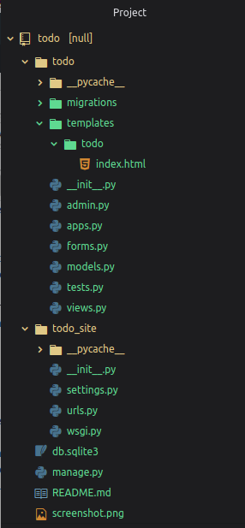

Now add todo app and crispy_form in your todo_site in **settings.py**.

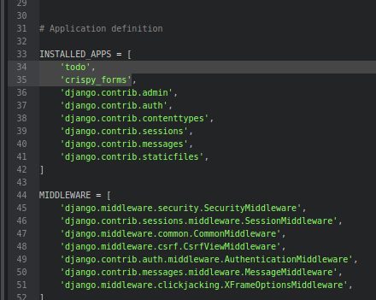

**Edit urls.py file in todo_site :**

from django.contrib import admin

from django.urls import path

from todo import views

urlpatterns = [

#####################home_page###########################################

path('', views.index, name="todo"),

####################give id no. item_id name or item_id=i.id ############

# pass item_id as primary key to remove that the todo with given id

path('del/<str:item_id>', views.remove, name="del"),

########################################################################

path('admin/', admin.site.urls),

]

**Edit models.py in todo :**

from django.db import models

from django.utils import timezone

class Todo(models.Model):

title=models.CharField(max_length=100)

details=models.TextField()

date=models.DateTimeField(default=timezone.now)

def __str__(self):

return self.title

**Edit views.py in todo :**

from django.shortcuts import render, redirect

from django.contrib import messages

## import todo form and models

from .forms import TodoForm

from .models import Todo

###############################################

def index(request):

item_list = Todo.objects.order_by("-date")

if request.method == "POST":

form = TodoForm(request.POST)

if form.is_valid():

form.save()

return redirect('todo')

form = TodoForm()

page = {

"forms" : form,

"list" : item_list,

"title" : "TODO LIST",

}

return render(request, 'todo/index.html', page)

### function to remove item, it receive todo item_id as primary key from url ##

def remove(request, item_id):

item = Todo.objects.get(id=item_id)

item.delete()

messages.info(request, "item removed !!!")

return redirect('todo')

**Now create a forms.py in todo :**

from django import forms

from .models import Todo

class TodoForm(forms.ModelForm):

class Meta:

model = Todo

fields="__all__"

**Register models to admin :** 

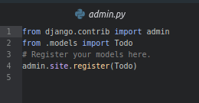

**Navigate to templates/todo/index.html and edit it :** [link to index.html file](https://github.com/itsvinayak/todo/blob/master/todo/templates/todo/index.html)  
**Make migrations and migrate it** 

python manage.py makemigrations

python manage.py migrate

Now you can run the server to see your todo app 

python manage.py runserver

